Practical no.5
Code:
print("**** Expenses ****")

expenses = 0.0
food = 0.0
shopping = 0.0
travelling = 0.0
other = 0.0

while True:
value = float(input("Enter your amount (-1 to stop): "))
if value == -1:
break

category = input("Enter your category (food/shopping/travelling/other): ").lower()

if category == "food":
food += value
elif category == "shopping":
shopping += value
elif category == "travelling":
travelling += value
else:
other += value

# Add every expense to the total
expenses += value

print("\n=== Expenses Summary ===")
print("Food:", food)
print("Shopping:", shopping)
print("Travelling:", travelling)
print("Other:", other)
print("Total Expenses:", expenses)
output: 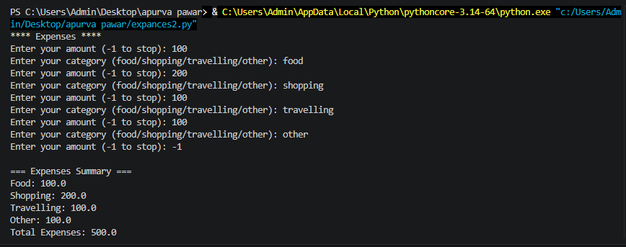

exersice
Q1.Write a program that uses a nested loop structure to generate a right angled triangle pattern of incrementing numbers ,where each row displays its corresponding row count index.
Code:
n = 5
for
i in range(1, n + 1):

for j in range(i):
print(i, end=" ")

print()
output: 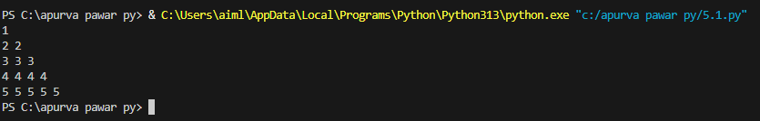

Q2.Build a script that prints a clean ,text based invoice frame border using rows and column of asterisk (*)characters.

Code:

rows = 8
columns = 30

for i in range(rows):
for j in range(columns):

if i == 0 or i == rows - 1 or j == 0 or j == columns - 1:
print("*", end="")
else:
print(" ", end="")
print()
output:

